**Project Day 3**

**TEAM GROUP M**

TEAM MEMBERS:

1. Chinmay Kulkarni (leader)
2. SV Kartikeya
3. Kartik MC
4. Hrithik Roshan

**Google colab link:**

https://colab.research.google.com/drive/1fEMKYPsUt-g04yS4loK-1r0EKViWwxQr#scrollTo=3o_XQTOuEmqM

**Problem Statement 10: (Fix the header)**

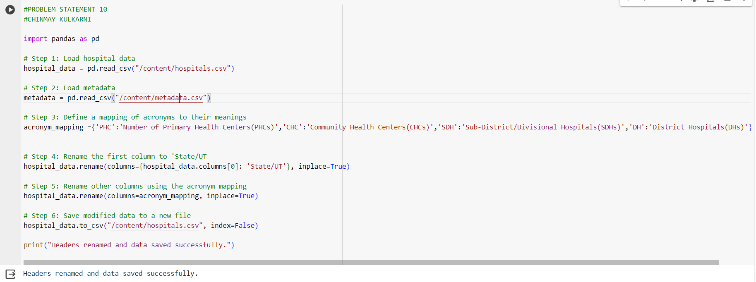

**Problem Statement 11: (Create a function to alter the data to create uniformity)**

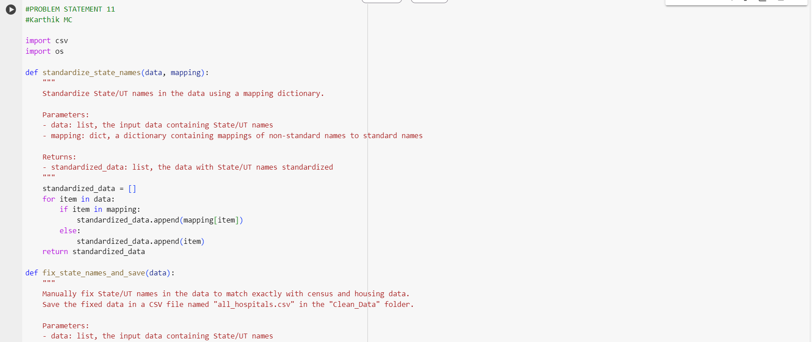

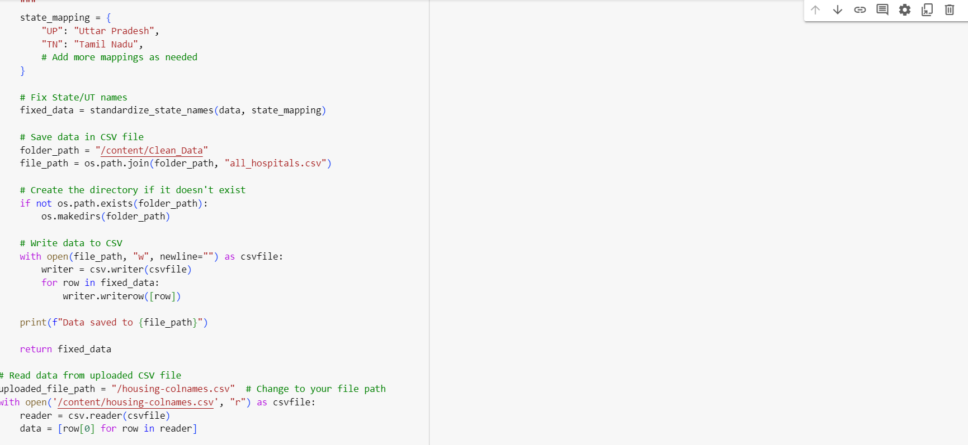

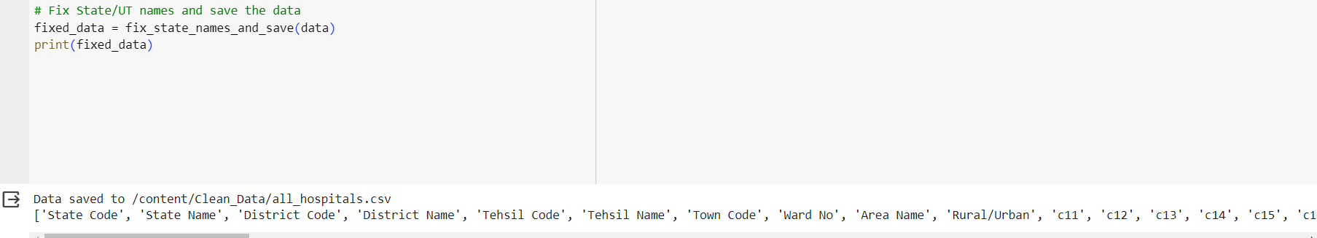

**Problem Statement 12: (Analyze Healthcare facility disparity)**

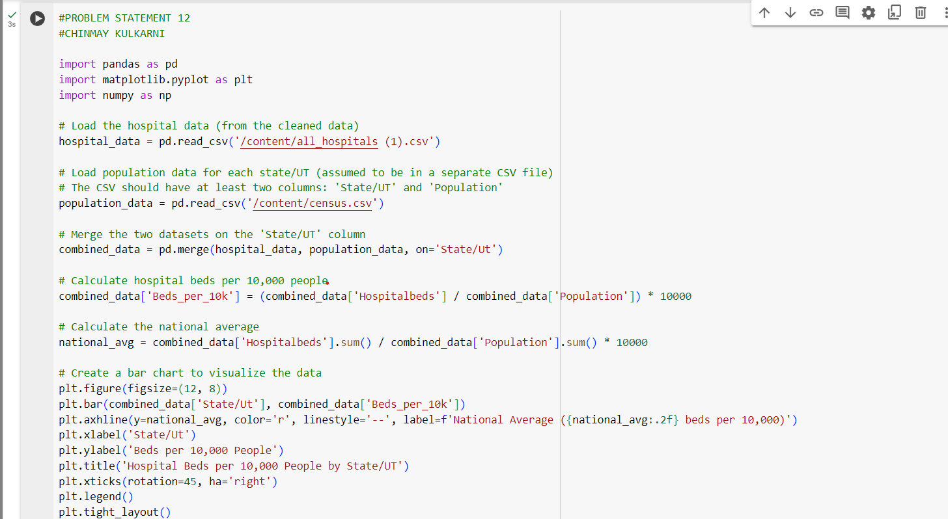

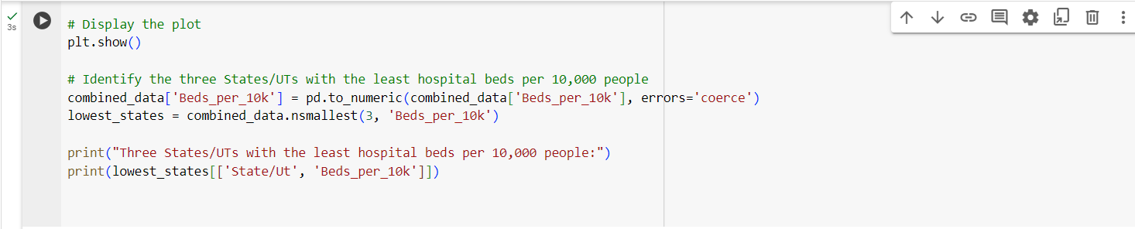

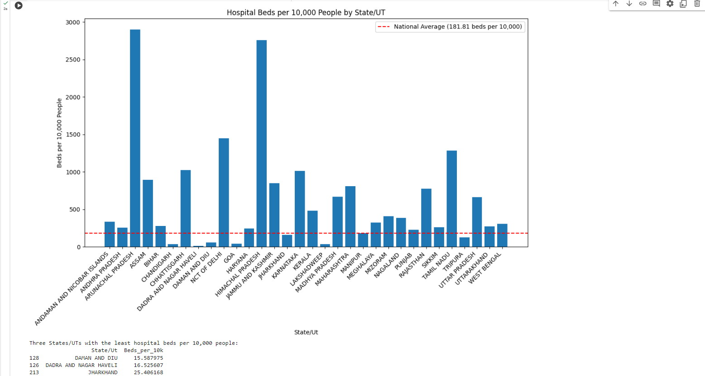

**Problem Statement 13: (Multi-line header)**

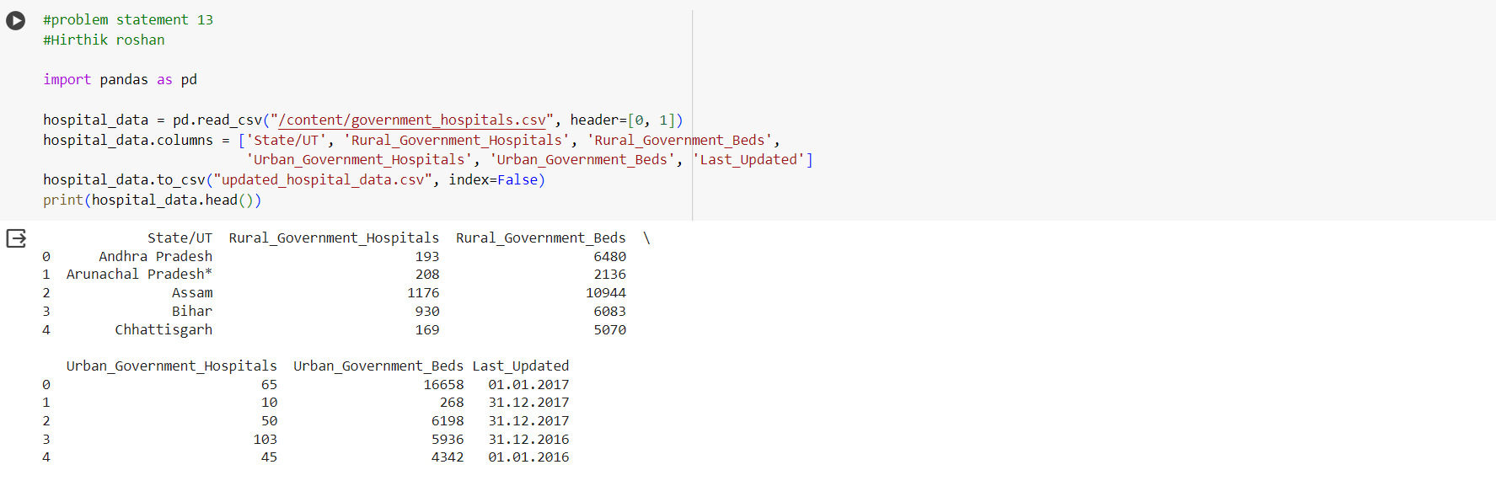

**Problem Statement 14: (Data update and code reuse)**

